# Create a List - Python Exercise

Below is the image provided along with the recreated question, terminal output, and answer:

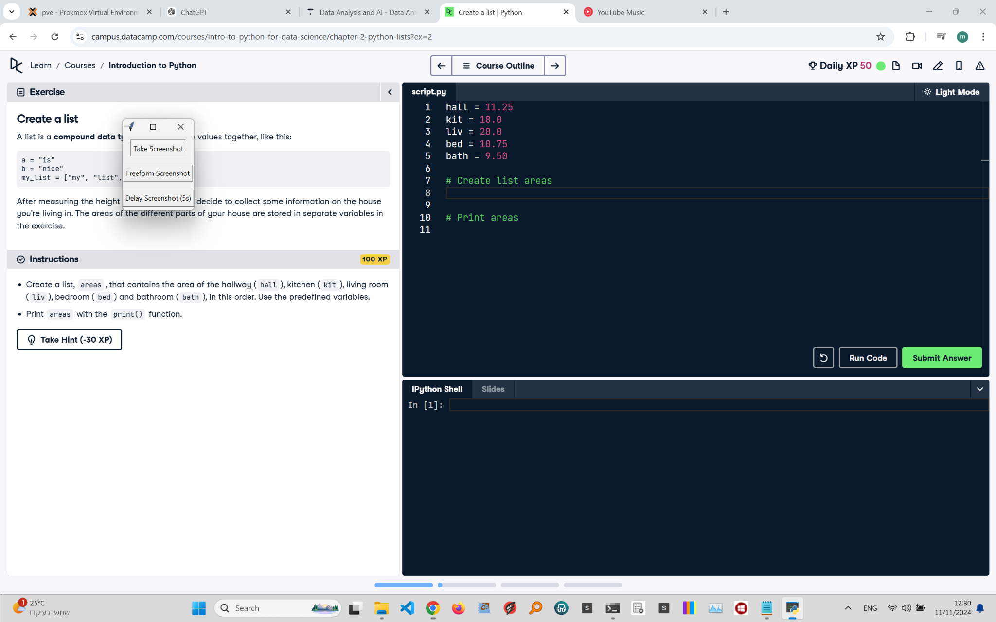

## Recreated Question and Terminal

Create a List  
A list is a compound data type that groups values together, like this:

a = "is"  
b = "nice"  
my_list = ["my", "list", a, b]

After measuring the height of your house, you decide to collect some information about the area of the different parts of your house. The areas of the hallway, kitchen, living room, bedroom, and bathroom are stored in variables: hall, kit, liv, bed, bath.  
  
Instructions:  
- Create a list, areas, that contains the area of the hallway (hall), kitchen (kit), living room (liv), bedroom (bed), and bathroom (bath) in this order.  
- Print areas using the print() function.

## Terminal Output

[11.25, 18.0, 20.0, 10.75, 9.5]

## Answer

# Given areas  
hall = 11.25  
kit = 18.0  
liv = 20.0  
bed = 10.75  
bath = 9.50  
  
# Create list areas  
areas = [hall, kit, liv, bed, bath]  
  
# Print areas  
print(areas)

## Explanation of the Answer

The code creates a list named areas using the provided room sizes. The print() function then outputs the list. Lists are useful because they store multiple values in a single variable, and the order matters, so each room’s size appears in the specified sequence.